**Project Planning 3**

**Demo**  
  
What you have done on the Project since last time?

-Created multiple Years datasets for our Heat Map

-Created multiple Sex (Male or Female) datasets for our Bar Chart

-Organized the dataset for our Line Graph

-Created/Improve Heat Map

-Created Line Graph

-Developing Bar Chart

-Planned and finding last dataset for Pie Chart.

-Created and designed our website.

-Drew 2 low fidelity sketches of our charts.

What you plan to complete before the next stand-up?

-Improve any imperfections in any of our current graphs/charts.

-Finish the project if possible.

What obstacles you are facing in completing your deliverables?

-Finding the last dataset and thinking of a factor for our pie chart.

**Submission**

***\*paste in text box on canvas***

List of what you have done since last standup.

-Search for datasets.

-Sort the datasets.

-Created Heat Map and Line Graph.

-Developing Bar Chart.

-Planning for Pie Chart.

-Created and designed our website.

**Image of our Datasets.**

For Heat Map

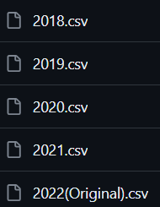

For Bar Chart

For Line Graph



For Bar Chart

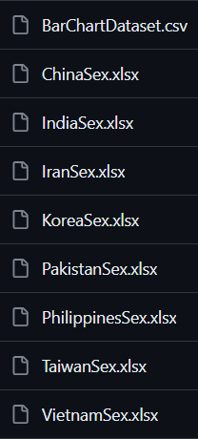

**Images of our low fidelity sketches of our charts**

**LFS of our Heat Map:**

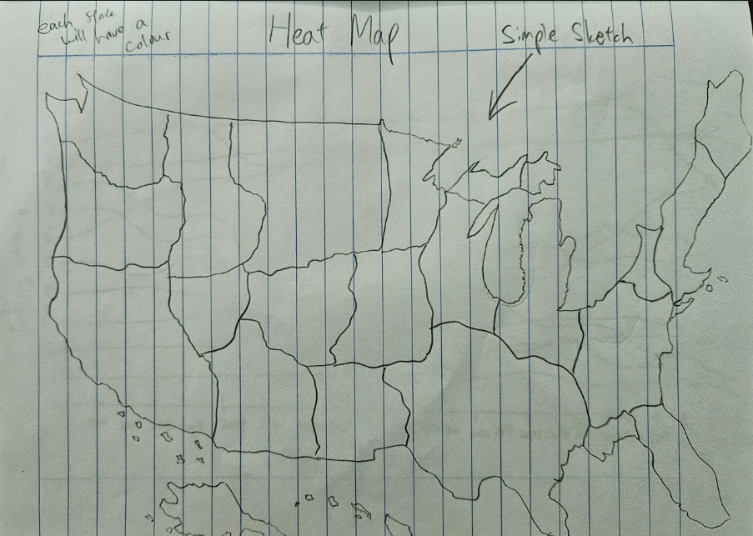

**LSF of our Line Graph:**

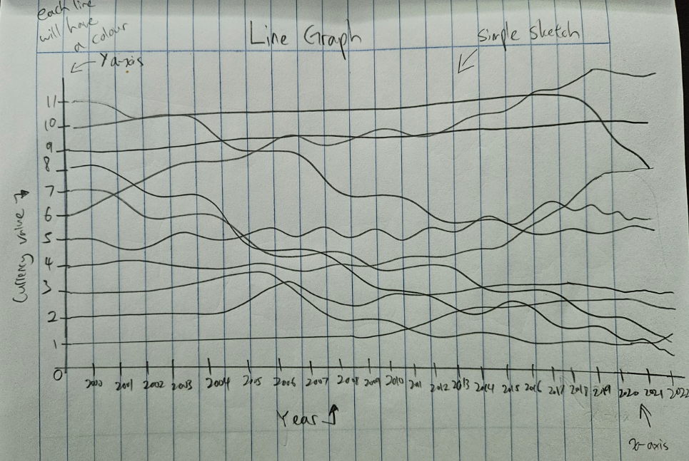

**Image of our Heat Map**

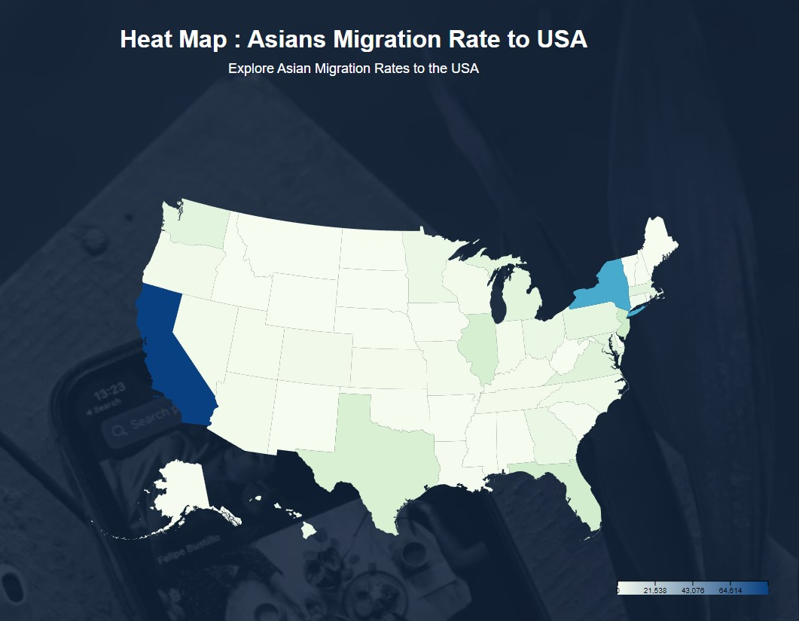

**Image of the coding for our Heat Map**

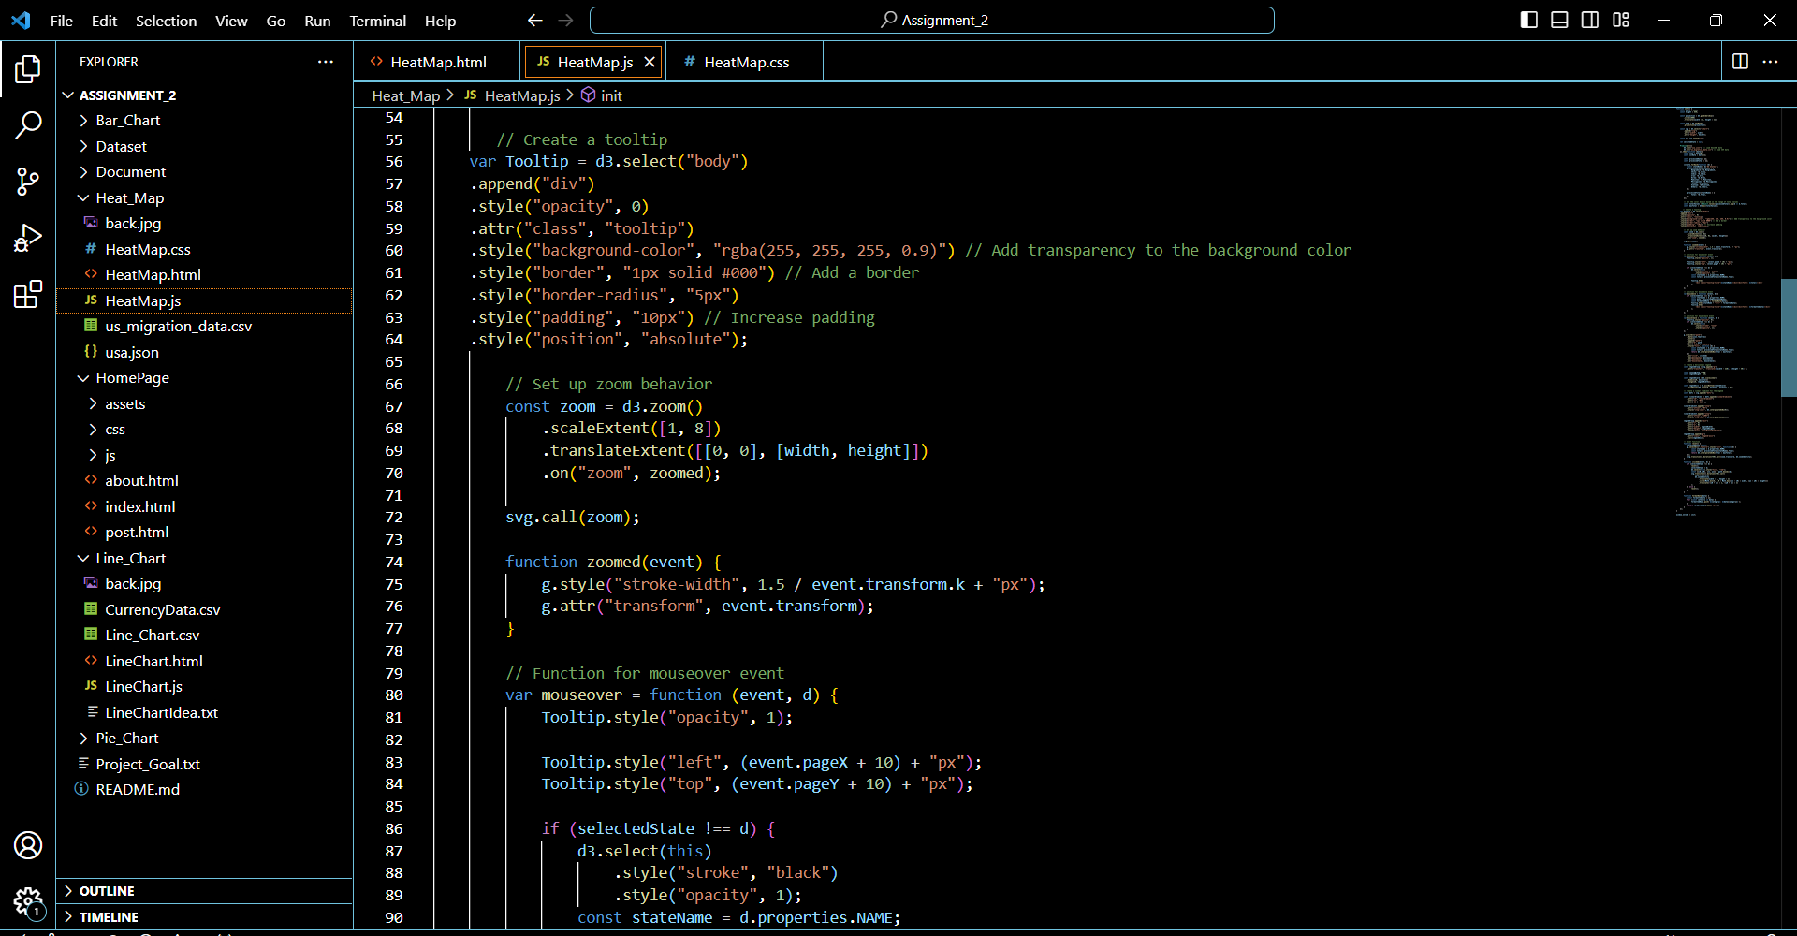

**Image of our Line Graph**

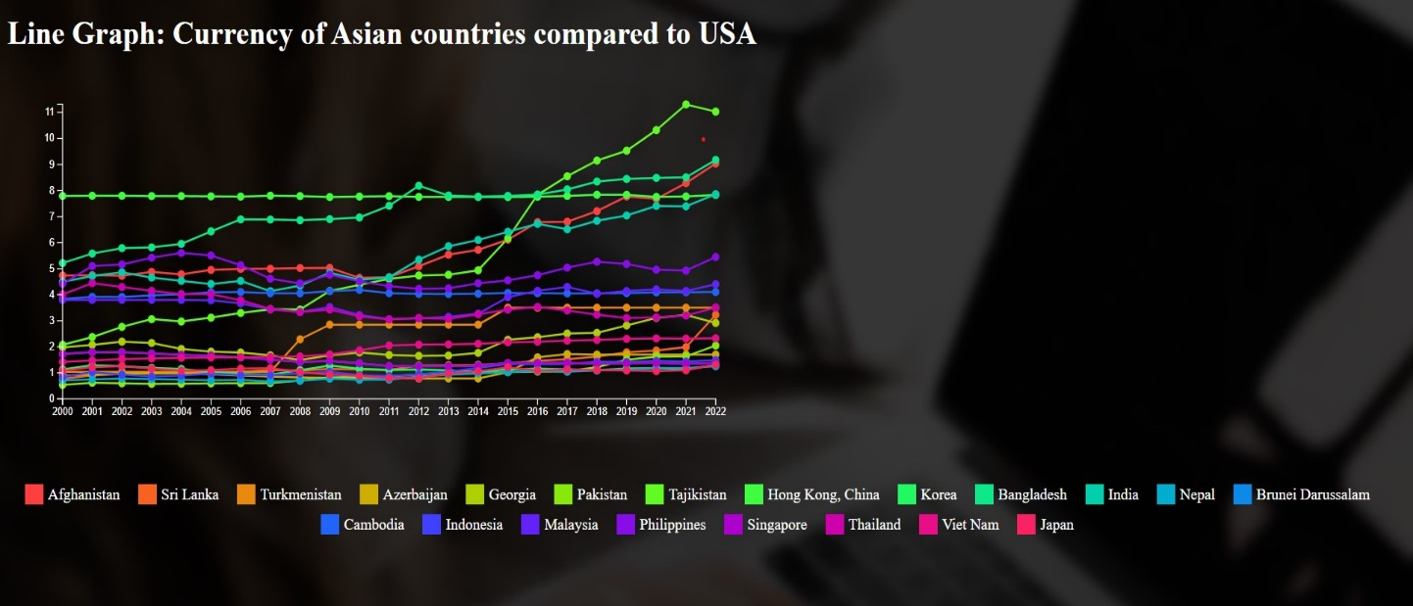

**Image of the coding for our Line Graph**

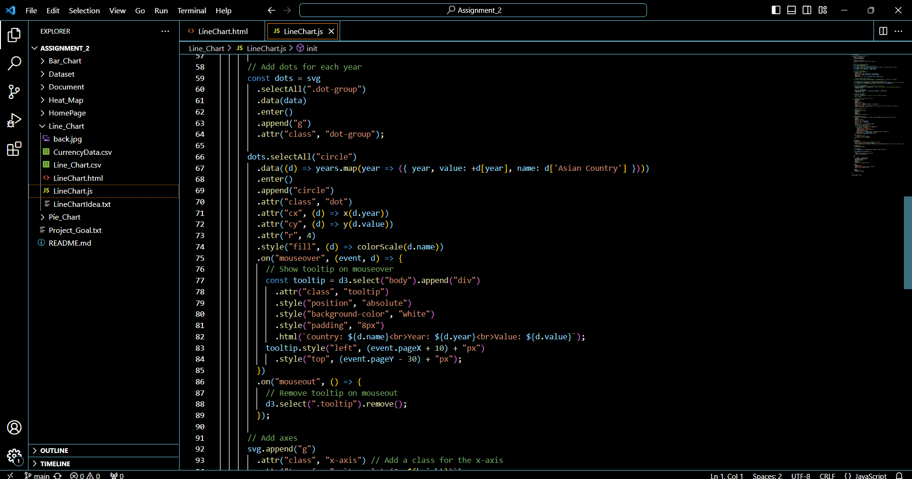

**Image of our Bar Chart (Still under development)**

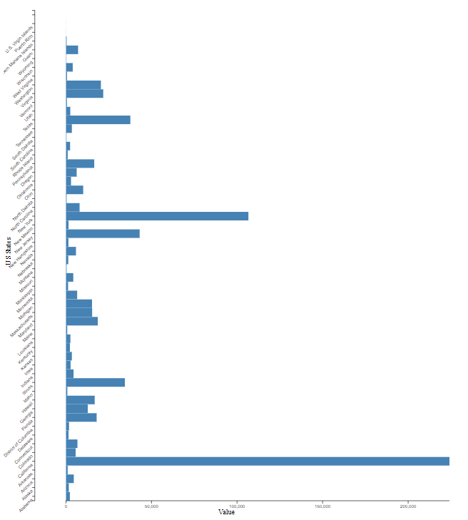

**Image of the coding of our Bar Chart**

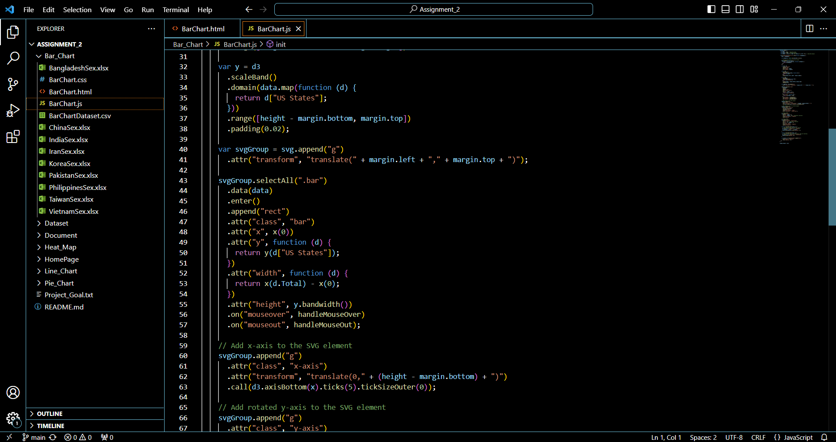

Estimate of your contribution (in hours and % of work completed by team so far) to:

|  |  |  |
| --- | --- | --- |
|  | Lam Mun Swee | Wan Zhen Yao |
| Finding and working with the data set | Time taken: 202 hours  Percentage of work completed: 90% | Time taken: 5 hours  Percentage of work completed: 10% |
| Designing the visualisation | Time taken: 3 hours  Percentage of work completed: 30% | Time taken: 10 hours  Percentage of work completed: 70% |
| Contributing to writing up the Process Book | Time taken: 2 hours  Percentage of work completed: 80% | Time taken: 1 hour  Percentage of work completed: 20% |
| Writing/researching code | Time taken: 4 hours *Mostly researching   Percentage of work completed: 25% | Time taken: 10 hours *Mostly writing  Percentage of work completed: 75% |

Summary of to-dos before next standup.

- Finding the last dataset and thinking of a factor for our pie chart.

-Try to complete the project.

Any issues with teamwork.

No.